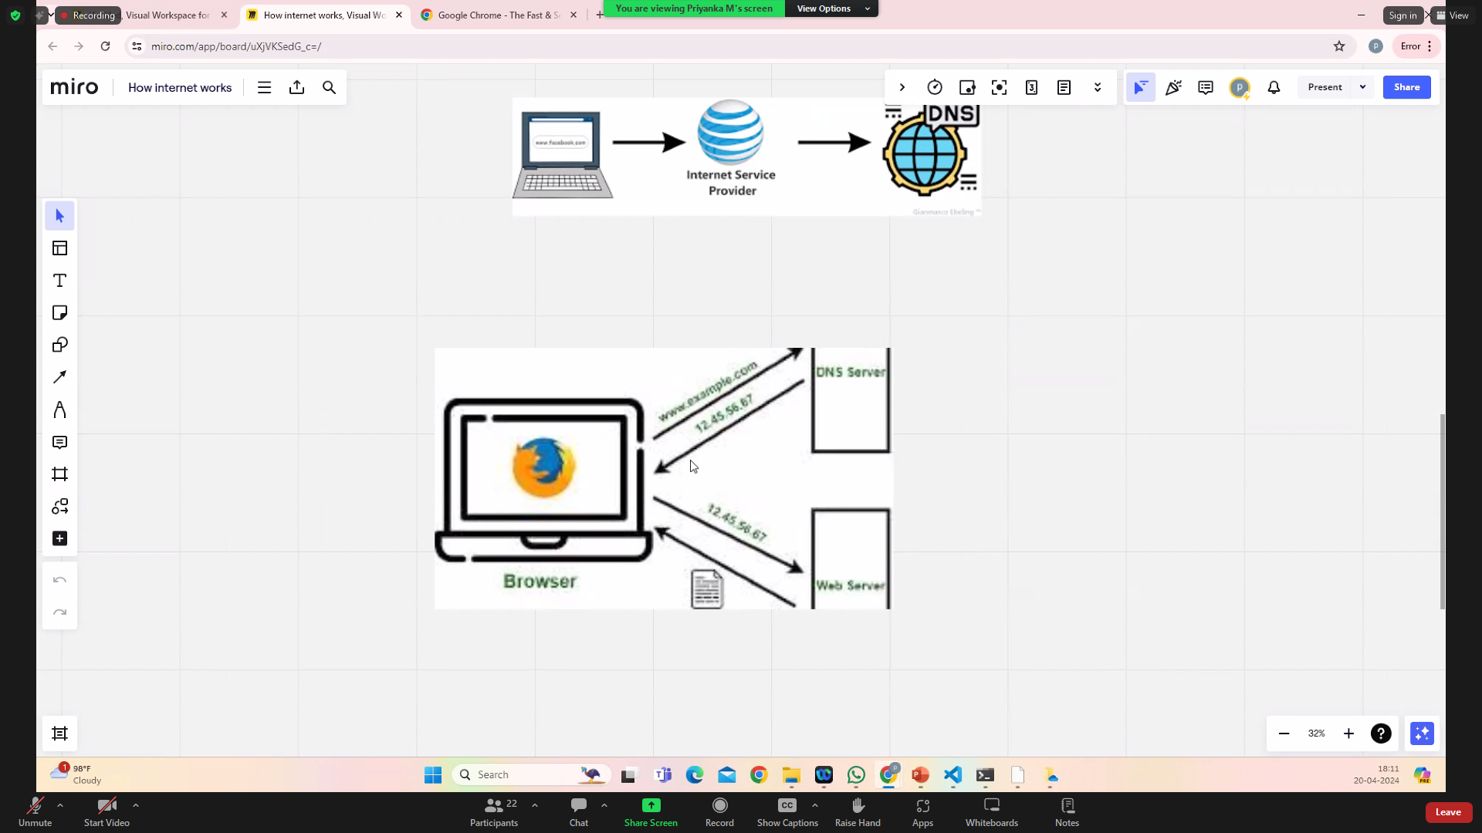

https://docs.google.com/document/d/1QznT1zM4mI6dG0TODx5Xjs1GquMoSHO3xZ1USDnVM-w/preview

version

Main

class

